**Passing table in method( class in se24)**

1. Go to se24.
2. Give class name starting with ZCL_. Click on create

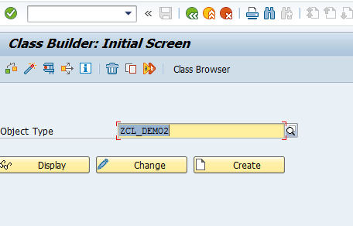

1. Give short description , choose Public and click Save

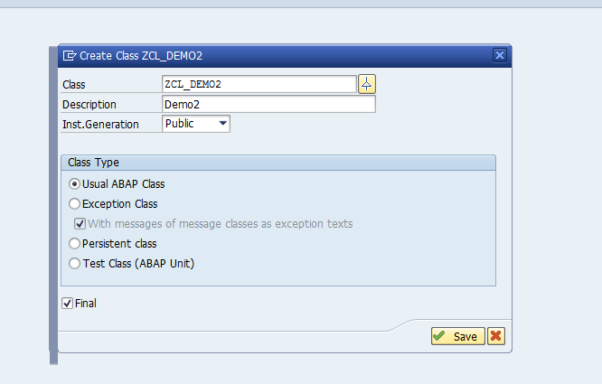

1. Go to Methods tab. Declare method FLIGHT_DETAILS as shown below

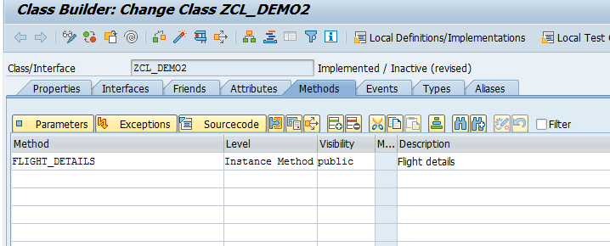

1. Keep the cursor on Method Flight_details and click on parameters

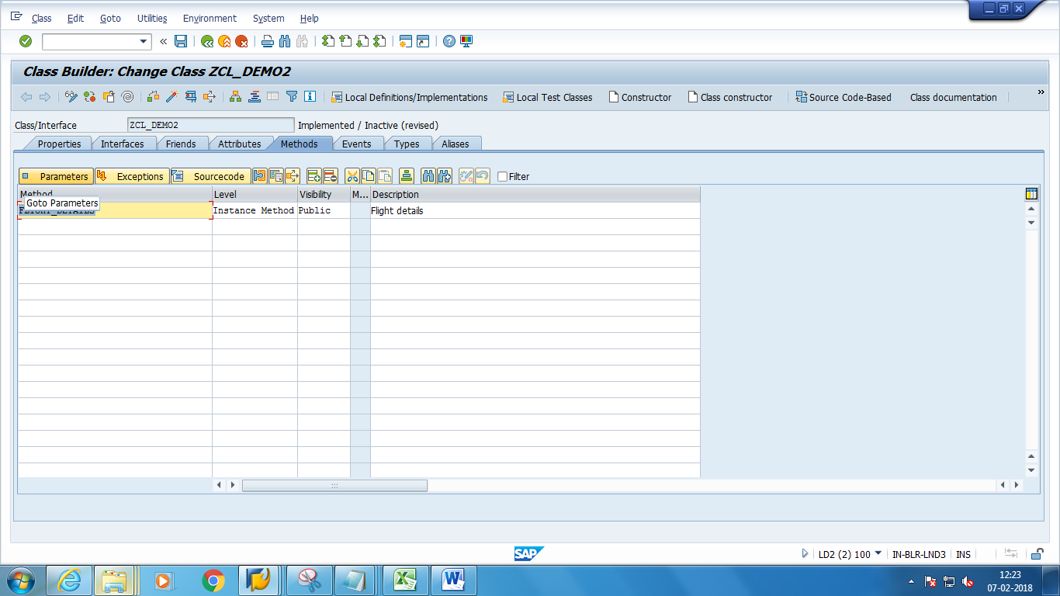

1. Add the following export import parameters

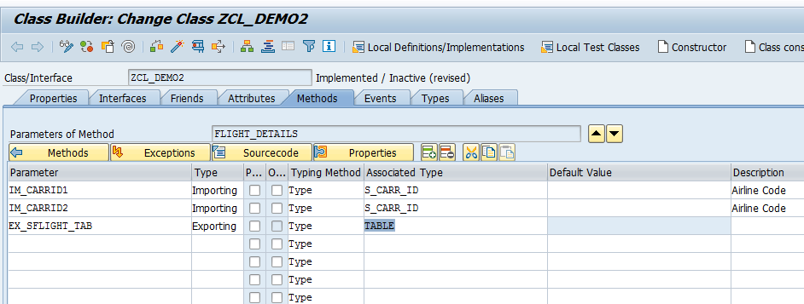

1. Click on source code and add the below code

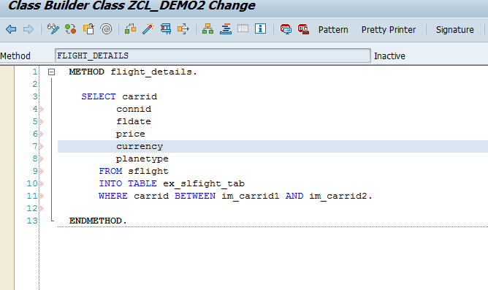

1. Save and activate the class.
2. Go to se38.Create a Report starting with Z
3. Add the below code in the Report.

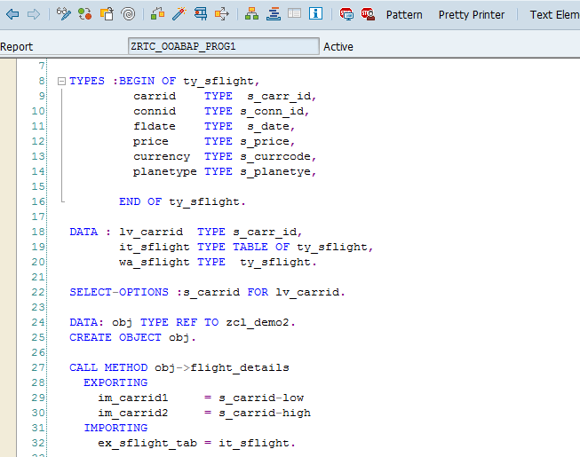

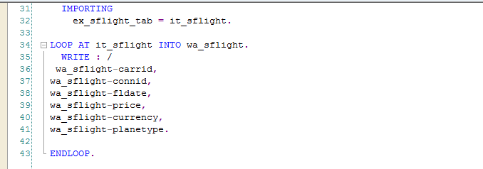

1. Save and activate the report. Execute. The expected output is as follows

